

1. **Match the content from section A with the ones given in section B statements by writing letter of the section B content in the middle area.**

|  |  |  |
| --- | --- | --- |
| **Section A** |  | **Section B** |
| a)Penicillin |  | a)contagious |
| b)Neutrophil activity is visible |  | b)antibody |
| c)Role of antibody |  | c)vaccines |
| d)Type of white blood cells cause yellow pus |  | d) First successful antibiotic |
| e)1st line of defence |  | e) cause pathogens to clump together and macrophages can destroy more at one time |
| f)To prevent spread of disease infected person should admitted into |  | f)2nd line of defence |
| g)Chemicals that cause body to react as if it had met a pathogen |  | g)Substances that kill or prevent growth of bacteria |
| h)Not identified as a white blood cell |  | h)neutrophils |
| i)Antibiotics |  | i)quarantine |
| j)Diseases that are easiest to spread are |  | j)skin |

2)

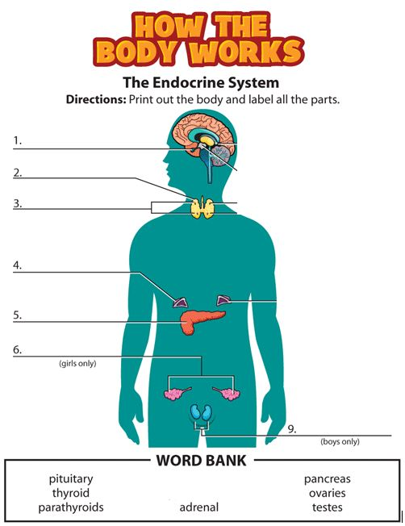

3) Outline the process used to make a vaccine. How this can be used to prevent infection?

----------------------------------------------------------------------------------------------------------------------------------------------------------------------------------------------------------------------------------------------------------------------------------------------------------------------------------------------------------------------------------------------------------------------------------------------------------------------------------------------------------------------------------------------------------------------------------------------------------------------------------------------------------------------------------------------------------------------------------------------------------------------------------------------------------------------------------------------------------------------------------------------------------------------------------------------------------------------------------------------------------------

4) Write the differences between antibiotics and vaccines.

------------------------------------------------------------------------------------------------------------------------------------------------------------------------------------------------------------------------------------------------------------------------------------------------------------------------------------------------------------------------------------------------------------------------------------------------------------------------------------------------------------------------------------------------------------------------------------------------------------------------------------------------------------------------------------------------------------------------------------------------------------------------------------------------------------------------------------------------------------------------------------------------------------------------------------------------------------------------------------------------------------------------------------------------------------------------------------------------------------------------------------------

5) Explain with the help of three lines of defence how the body can prevent infection.

-------------------------------------------------------------------------------------------------------------------------------------------------------------------------------------------------------------------------------------------------------------------------------------------------------------------------------------------------------------------------------------------------------------------------------------------------------------------------------------------------------------------------------------------------------------------------------------------------------------------------------------------------------------------------------------------------------------------------------------------------------------------------------------------------------------------------------------------------------------------------------------------------------------------------------------------------------------------------------------------------------------------------------------------------------------------------------------------------------------------------------------------------------------------------------------------------------------------------------------------------------------------------------------------------------------------------------------------------------------------------------------------------------------------------------------------------------------------------------------------------------------------------------------------------------------------------------------------------------------------------------------------------------------------------------------------------------------------------------------------------------------------------------------------------------------------------------------------------------------------------------------------------------------------------------------------------------------------------------------------------------------------------------

6) Define the term disease.

----------------------------------------------------------------------------------------------------------------------------------------------------------------------------------------------------------------------------------------------------

7) State the general name for organisms that cause disease.

--------------------------------------------------------------------------------------------------------------------------

8) What are the common allergy symptoms? What treatment can be given for an allergic reaction?

-------------------------------------------------------------------------------------------------------------------------------------------------------------------------------------------------------------------------------------------------------------------------------------------------------------------------------------------------------------------------------------------------------------------------------------------------------------------------------------------------------

-------------------------------------------------------------------------------------------------------------------------------------------------------------------------------------------------------------------------------------------------------------------------------------------------------------------------------------------------------------------------------------------------------------------------------------------------------------------------------------------------------

----------------------------------------------------------------------------------------------------------------------------------------------------------------------------------------------------------------------------------------------------

9) Describe how vaccines are created and how they work within the body to prevent infection.

------------------------------------------------------------------------------------------------------------------------------------------------------------------------------------------------------------------------------------------------------------------------------------------------------------------------------------------------------------------------------------------------------------------------------------------------------------------------------------------------------------------------------------------------------------------------------------------------------------------------------------------------------------------------------------------------------------------------------------------------------------------------------------------------------------------------------------------------------------------------------------------------------------------------------------------------------------------------------------------------------------------------------------------------------------------------------------------------------------------------------------------------------------------------------------------------------------------------------------------------------------------------------------------------------------------------------------------------------------------------------------------------------------------------------------------------------------------------------------------------------------------------

10) What is the difference between infectious and contagious disease.

------------------------------------------------------------------------------------------------------------------------------------------------------------------------------------------------------------------------------------------------------------------------------------------------------------------------------------------------------------------------------------------------------------------------------------------------------------------------------------------------------------------------------------------------------------------------------------------------------------------------------------------------------------------------------------------------------------------------------------------------------------

11. Match the hormone with the function.

|  |  |
| --- | --- |
| **Hormone** | **Function** |
| 1. Antidiuretic hormone | control water levels in the blood |
| 1. Insulin | Lowers blood glucose level |
| 1. Epinephrine ( Adrenalin) | Increases body metabolism in ‘fight or flight’ response |
| 1. Thyroid stimulating hormone | Changes the rate of thyroxine release from the thyroid |

12. Name a hormone , its origin, its target organ, and the effects it makes in the body.

Hormone: -------------------------------------------------------------------

Origin:------------------------------------------------

Target organ:---------------------------------------

Effects: -----------------------------------------------------------------------------------------------------------------------------------------------------------------------------------------------------------------------------------------------------------------